**MODERN PHYSICS**

Modern physics deals with the nuclear model of an atom.

**STRUCTURE OF AN ATOM**

An atom consists of 3 particles namely -:**Proton , Neutrons** and **Electrons.**

The *neutrons* and *protons* are found in the nucleus and are referred to as **nuclei particles or nuclide particles.**

|  |  |  |
| --- | --- | --- |
| **Name** | **Symbol** | **Sign of change** |
| Protons | J:\ms6.png | Positive |
| Neutrons | J:\ms7.png | No change |
| Electrons | J:\ms8.png | Negative |

* Protons are heavier than electrons.
* Protons are equivalent to a positive hydrogen ion.

**ISOTOPES**

***Isotopes*** are atoms of the same element having the same atomic number but different mass number.

**ATOMIC NUMBER**

***Atomic number*** is the number of protons in the nucleus of an atom.

Symbol for atomic number is Z.

**MASS NUMBER**

***Mass number*** is the sum of protons and neutrons in a nucleus of an atom. It is sometimes called atomic mass.

It is expressed using the letter A.

**Note:** ***Mass number = Atomic number + No. of Neutrons.***

**A = Z + N**

***An atom is usually electrically neutral, implying that the number of protons, Z is equal to its number of electrons.***

An atom X is represented by : Where A = atomic number and Z = mass number

e.g. J:\f3.png has 17 protons and 18 neutrons

**QUESTIONS:**

1. Given the atom : , Find its
2. atomic mass
3. atomic number
4. number of neutrons
5. number of electrons.
6. Describe the potassium atom represented by the symbol .

**RADIOACTIVITY**

**Definition:**

***Radioactivity*** is the spontaneous disintegration (or continuous breaking) of heavy unstable nuclei to form stable nuclei with emission of radiations e.g ***beta particles (***β***) , gamma rays(***γ***), alpha particles*** (α) .

**A RADIO ACTIVE ELEMENT**

Is one whose nucleus spontaneously disintegrates and continuously emits powerful and invisible radiations.

**DIFFERNCES BETWEEN RADIATIONS**

|  |  |  |
| --- | --- | --- |
| **Alpha (α) particle** | **Beta (β) particle** | **Gamma rays (γ)** |
| An alpha particle is a helium particle, | Beta particles are streams of high-energy electrons,  (β = ) | Gamma rays are electromagnetic waves. |
| are positively charged | are negatively charged | have no charge. |
| are less deflected by both magnetic and electric fields | are more deflected by both magnetic and electric fields | are not deflected by both magnetic and electric fields |

**BEHAVIOUR IN AN ELECTIC FIELD**

* The alpha particles are deflected towards the negative plate indicating that they are positively charged. (Less deflected because they are heavy.)
* The beta particles are deflected towards positive plate indicating that they are negatively charged. (sharply deflected because they are very light.)
* While gamma rays go through the field without being deflected showing that they carry no charge.

**_**

**+**

α - particles

γ - rays

β - particles

**DEFLECTION BY A MAGNETIC FIELD**

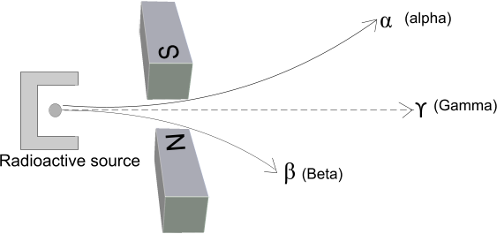

* The beta particle is deflected downwards (towards the N- pole) because they are negatively charged. They are sharply deflected because they are very light.
* The alpha particles are deflected upwards (towards the S- Pole) according to Flemings left hand rule because they are positively charged. They are less deflected because they are heavy.
* Gamma rays are not deflected because they possess no charge.

α ()

γ - rays

β ()

β (Beta)

γ -rays

α (Alpha)

1. *Magnetic field direction is into the paper*. (ii) *Magnetic field direction is out of the paper*

**PENETRATION OF MATTER:**

* Alpha particles have low penetrating power and are easily stopped by a thin sheet of paper. They do not travel far in air because they are easily slowed down by collisions with air molecules.
* Beta particles are more penetrative than alpha particles but less penetrative than gamma rays. They are stopped by thick paper, Perspex glass and thin aluminum.
* Gamma rays possess the greatest penetrative power of the three radiations. They are stopped by thick lead or concrete. They travel in a straight line in air (under almost no diffraction).

β

𝞪

γ

γ

β

γ

Thin sheet of paper.

Thick paper or glass or thin lead

Thick lead or concrete

**IONIZATION OF AIR**

* Alpha particles have the highest ionizing effect because they are heavy and carry a larger charge than beta particles.
* Beta particles are less ionizing than alpha particles because the possess a smaller charge and are very light.
* Gamma rays are the poorest ionizers of the three radiations.

**TRACKS OF THE THREE RADIATIONS AS DEMONSTRATED IN A CLOUD CHAMBER**

When a radioactive source emits particles in an air space saturated with water vapour or alcohol vapour inside a vessel with a glass window, the speeding particles collide with the air molecules with great force knocking off electrons, and leaving a trail of positive and negative ions.

If the air space is suddenly expanded by moving the piston, cooling occurs and the vapour condenses out on the ions, thus revealing the paths of the particles.

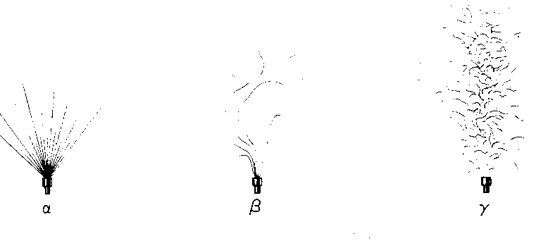

**ALPHA PARTICLES**

* Are short straight and bold tracks, this is because they are good ionizers of gas. A large number of ions are observed. The tracks differ in length due to difference in energy

**BETA PARTICLES**

* Tracks made by beta particles are longer and fainter.
* They wonder as they are easily deflected by air molecules because beta particles are light compared to the heavier air molecules that they collide with.

**GAMMA RAYS**

* Gamma rays don’t leave an actual track because they don’t ionize gas. However, they may give part or the whole of their energy to air molecules they collide which in turn behave like beta particles leaving behind whisky or wavy tracks.

**FLUORESCENCE:**

Only alpha particles cause fluorescence when they are incident on a fluorescent screen.

**NUCLEAR EQUATIONS**

**Alpha decay:**

*Parent nuclide = Daughter nuclide + 𝞪 – particle + energy*

RULE 1 : When an element disintegrates (decays) by emission of an alpha particle, it turns into an element two places earlier in the periodic table.

**Beta decay:**

*Parent nuclide = Daughter nuclide + β – particle + energy.*

RULE 2: When an element disintegrates (decays) by emission of a beta particle, it turns into an element one place later in the periodic table.

**Gamma Decay:**

*Gamma rays are emitted as a result of instability in the nucleus. Therefore Gamma rays are emitted so that the nucleus acquires a more stable state.*

*The emission of Gamma rays causes no change in the atomic and mass numbers of the element.*

**EXAMPLES:**

1. A radioactive substance J:\ms3.png undergoes decay and emits an alpha particle to form Y .Write down an equation for the process.

**SOLUTION**

An equation for the process

J:\f4.png

J:\f5.png

2. Unstable nuclei J:\f7.png decays to form a stable nuclei Y and a beta particle is emitted.

Write down an equation for the process.

**SOLUTION**

J:\f8.png

3. Radium loses 5 α – particles and 4 β particles and is converted into a new stable element, an isotope of lead Pb. Find the mass number and atomic number of this isotope.

**SOLUTION**

Mass number of the isotope is,

Also

Atomic number of the isotope is, Z = 82

4. Thorium is converted into Radium by radioactivity transformation. How many α and β emissions have taken place?

**SOLUTION**

Change in Atomic Number:

……………………………………..(1)

Change in Mass Number:

, therefore .

There are 2 α – particles and 2 β – particles.

**ARTIFICIAL RADIOACTIVITY:**

Artificial radioisotopes of some elements can be prepared by bombarding nuclei of stable atoms with α - particles, β – particles or neutrons.

The process of producing artificial radioactive nuclides is a reverse process of the decay process i.e. stable nuclei absorb nuclear particles of gamma photons which strike them, and they become unstable as a result.

**RADIOISOTOPES:**

A ***radioisotope*** is an unstable isotope produced by bombarding a stable nuclide with either alpha particles, beta particles or neutrons.

**NOTE:**

Since radioisotopes are unstable, they can decay with the emission of α-, β- , or γ radiations to acquire a more stable state.

**EXAMPLES:**

1. When the nucleus of Aluminium is bombarded by an α – particle, a radioactive isotope of Phosphorus is obtained.

*neutron*

*Phosphorus*

*isotope*

*Apha*

*particle*

*Aluminium*

*nucleus*

*Radioisotope of sodium used in medicine*

*Normal stable sodium neuclide*

*neutron*

*Radioisotope of iodine used in medicine*

*l stable iodine neuclide*

*neutron*

**USES OF RADIOISOTOPES:**

1. **Agricultural uses**

* Used in tracer techniques to investigate the flow of liquids in chemical plants.
* Used to induce plant mutations to provide better seed varieties.

1. **Industrial uses:**

* Used in the automatic control of thickness of material in industries.
* Used in the study of wear and tear in machinery. (detecting underground leakages in pipes)
* Gamma ray are used to detect faults or cracks in metal sheets or welded joints.
* Used in packaging processes by counting the correct amount or number per packet.

1. **Medical uses:**

* used in treatment of cancer.
* They are used to kill bacteria in food (x- rays)
* Used to sterilize medical equipment like syringes.
* Used in the diagnosis and treatment of goiter.

1. **CARBON DATING:**
2. **Archeology**

* Used to determine the time that has elapsed since death of organisms occurred in a process called **carbon dating.**

1. **Geology**

* They are used to determine the age of rocks.

**DANGERS (HAZARDS) OF RADIATIONS FROM RADIOACTIVE SUBSTANCES.**

* Beta and alpha particles cause skin burns and sores.
* Can cause cancer and affect eye sight.
* May cause infertility and sterility, (reproductive organs and liver).
* May lead to genetic mutations.

**SAFETY PRECAUTIONS WHEN DEALING WITH RADIOACTIVE SOURCES**

* Radioactive sources must be kept in lead boxes.
* Handle radioactive materials using tweezers.
* Workers should wear protective lead suits (protective clothing)
* Walls of industries are made of thick strong concrete to prevent exposure to surroundings.
* Using radioactive materials of short half – life
* Washing body thoroughly after exposure to radioactive materials.
* Avoid eating or drinking around radioactive sources.

**Back ground radiation**

These are radiations which naturally exist even in the absence of radioactive source. They are caused by natural tracks of radioactive materials in rocks, in air, cosmic rays from outer space as well as bricks of buildings.

Cosmic rays are very high energetic radioactive particles which come from deep in space.

So the

e.g.

Given that the back-ground rate is 2 counts, per minute and the Geiger Muller count rate determine the approximate number of radiations present.

**NUCLEAR ENERGY**

***Nuclear energy*** is the type of energy made available from the disintegration of the nucleus of an atom.

1. **NUCLEAR FISSION**

***Nuclear fission*** is the splitting of nucleus of heavy atoms into two lighter nuclei of roughly equal mass.

The process Nuclear fission can be started by the bombardment of a heavy unstable nuclei with a neutron. The products of the process are two lighter atoms and more neutrons which can make the process continue.

The two lighter products of nuclear fission are called **fission products** or **fission fragments**.

They have less mass than the correct value. The difference in their mass is due to energy loss which is given by the Einstein equation.

E = mc2 where c is the speed of light and m is the mass difference (or defect)

The neutrons produced after nuclear fission are called **fission neutrons**.

Fission neutrons ensure the continuity of nuclear fission indefinitely, resulting into a ***chain reaction***.

**EXAMPLE OF NUCLEAR FISSION EQUATION:**

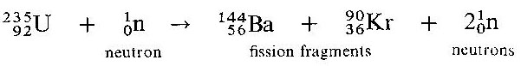

**ILLUSTRATION OF A CHAIN REACTION:**

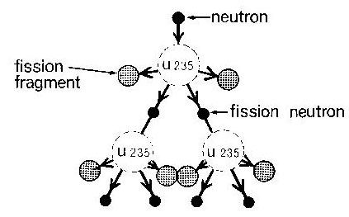

**APPLICATION OF NUELEAR FISSION:**

* Used in making atomic bombs.
* Used to generate electricity.
* Used to generate heat energy on large scale.

**CONDITIONS NECESSARY FOR NUCLEAR FISSION TO OCCUR:**

1. There should be neutrons *moving at a high speed* that meet and are captured by the heavy nuclei to make it unstable.
2. There should be a heavy unstable nucleus with isotopes which decay to produce isotopes and high speed neutrons.

**2 NUCLEAR FUSION**

***Nuclear fusion*** is the union of two light atomic nuclei to form a heavy atom with the release of energy.

***EXAMPLE OF NUCLEAR FUSION EQUATION.***

J:\ms4.png

J:\ms5.png

**CONDITIONS NECESSARY FOR NUCLEAR FUSION TO OCCUR**

* Temperatures must be very high.
* The light nuclei should be at very high speed to overcome strong repulsive forces between their charges.

**USES OF NUCLEAR FUSION:**

* Used to produce hydrogen.
* In the production of the Hydrogen bomb.
* Used to produce electricity.
* Used to produce heat energy on large scale.

Fusion reactions are sometimes known as **thermonuclear** reactions because thermo energy has to be supplied before energy can be released.

**NOTE:** 1. ***The Sun produces its energy by nuclear fusion***. In the sun’s core, vast quantities of energy are released as thermonuclear reactions convert hydrogen into helium.

**2.** The hydrogen bomb is a result of an uncontrollable fission chain reaction supplying heat needed for the thermonuclear reaction to start.

**CHALLENGES IN ACHIEVING CONTROLLED NUCLEAR FUSION:**

1. No ordinary container can withstand the high temperatures required for nuclear fusion to start and resist the expansion of the hydrogen so that the reactions can be maintained.

**HALF LIFE:**

**Definition:** I

***The half – life of a radioactive substance, t is the time taken for the radioactive substance to decay to half of its original mass.***

***EQUATION OF HALF – LIFE:***

Where

M is the mass present after time T.

Mo is the original mass

t is the half – life of the radioactive substance

T is the total time taken for the mass to decay from Mo to M

**Calculations**

**EXAMPLE 1**

If a radioactive element of mass 32 decays to 2g in 96 days. Calculate the half-life.

METHOD 1

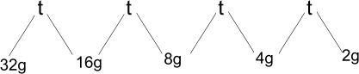

days, is the half – life.

METHOD 2: FORMULA.

Formula; ; substituting in formula:

Therefore implying that

Comparing indices: therefore .

METHOD 3: TABLE FORM

|  |  |  |
| --- | --- | --- |
| No. of half - lives | Time taken | Amount present |
| 0 | 0 | 32g |
| 1 | T | 16g |
| 2 | 2t | 8g |
| 3 | 3t | 4g |
| 4 | 4t | 2g |

Where t = the half-life

therefore, 4t = 96 days

.

**EXAMPLE 2:**

A certain radioactive substance takes 120years to decay from 2g to 0.125g . find the half life

Let the half – life be t

METHOD 1.

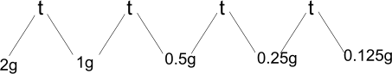

4 t = years.

METHOD 2: FORMULA.

Formula; ; substituting in formula

Therefore implying that

Comparing indices: therefore .

METHOD 3: TABLE FORM

|  |  |  |
| --- | --- | --- |
| No. of half - lives | Time taken | Amount present |
| 0 | 0 | 2g |
| 1 | T | 1g |
| 2 | 2t | 0.5g |
| 3 | 3t | 0.25g |
| 4 | 4t | 0.125g |

Where t = the half-life

therefore, 4t = 120 days

.

**EXAMPLE 3:**

The half-life of substance is 5 days. find how long it takes for its mass to disintegrate from 64g to 2g

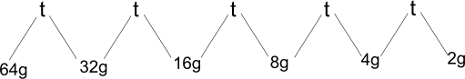

1. A radioactive element has a half-life of 4years. If after 24hours, 0.15g remains, calculate the initial mass of the radioactive material.

**Solution**: Working backwards starting from mass present to original mass.

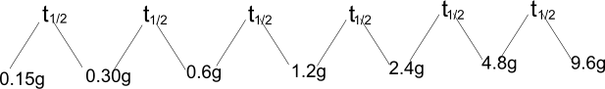

Mo = 9.6 g

1. A certain mass of a radioactive material contains atoms, how many atoms decayed after 3200 years if the half-life of material is 1600 years

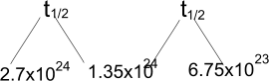

Mass remaining = 6.75 x 1023 atom

Mass that decayed = original mass - mass remaining

= (2.7 x 1024 - 6.75 x 1023)

= 2.025 x 1024 atoms

**GRAPHICAL METHOD OF DETERMINING HALF LIFE**

When a graph of count rate against time of radioactive nuclei is drawn, the half life of the radioactive nuclei can be determined as below.

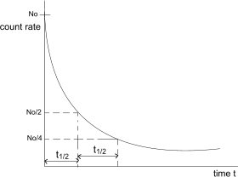

Example 1

The following values obtained from the readings of a rate meter from a radioactive isotope of iodine

|  |  |  |  |  |  |
| --- | --- | --- | --- | --- | --- |
| Time (min) | 0 | 5 | 10 | 15 | 20 |
| Count rate (min -1) | 295 | 158 | 86 | 47 | 25 |

Plot a suitable graph and find the half-life of the radioactive iodine.

2. The following figures were obtained from Geiger Muller counter due to disintegration of a sample of radon gas

|  |  |  |  |  |  |  |
| --- | --- | --- | --- | --- | --- | --- |
| Time(min) | 0 | 1 | 3 | 4 | 7 | 9 |
| Count-rate \min-1 | 6400 | 5380 | 3810 | 2700 | 1910 | 1350 |

a) i) plot a graph of count rate against time

ii) Determine the half-life.

iii) Find the missing values.

b) i) What is the count rate after 200 minutes

ii) After how many minutes is the count rate 1000 minutes.

**THERMIONIC EMISSION**

*This is the process by which electrons are emitted from a hot metal surface.*

**EXPLANATION OF THERMIONIC EMISSION.**

When a metal is heated to a certain temperature, some of its electrons gain sufficient energy to overcome the electrostatic attractive forces and break free from the metal surface and escape into the surrounding space.

**NOTE:**

***Thermionic emission increases with temperature***.

**CATHODE RAYS**

**Cathode rays** are streams of fast moving electrons.

**PRODUCTION OF CATHODE RAYS**

The circuit is connected as shown

Beam of

electrons

Fluorescent

screen

Evacuated Glass

tube

Anode with a

hole

Hot Filament

cathode

3.5 kV (E.H.T)

6.0 V (a.c.)

* The cathode is a tungsten filament heated by a low a.c. voltage of about 6.0 V such that it emits electrons by method of thermionic emission.
* The large p.d of about 3.5 kV across the anode accelerates the electrons from cathode towards the anode. The fast moving electrons pass through the anode and strike the fluorescent screen such it glows.
* The glass tube is evacuated to ensure that electrons move freely so that they don’t collide with the relatively heavier air molecules.

**PROPERTIES OF CATHODE RAYS**

1. They carry a negative charge (since they are fast moving electrons).
2. They are deflected by both electric and magnetic fields.
3. They ionize gases.
4. They cause some substance to fluorescence i.e. give off light when they strike the surface.
5. They travel in a straight line.
6. In an electric field, cathode rays are deflected towards the positive plate and in the magnetic field, the direction of deflection is determined using Flemings left hand rule.
7. They possess energy.
8. They can cause certain metals to produce X – rays when they are incident on them.

**Deflection of cathode rays by an Electric field.**

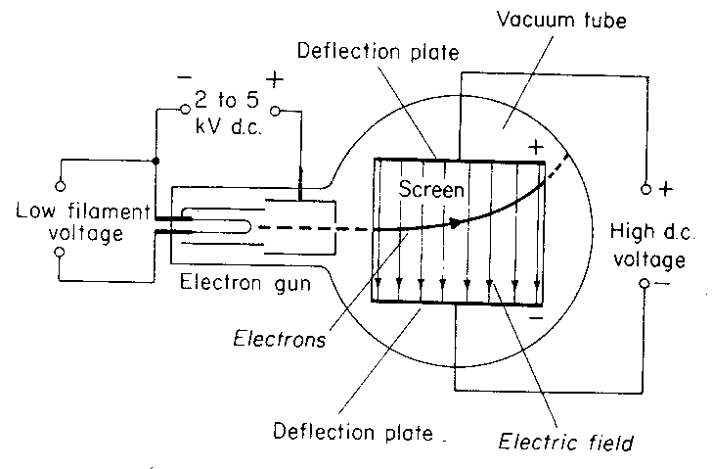

* ***Cathode rays are deflected toward the positive plate by an electric field.***

**Deflection of cathode rays by a Magnetic field.**

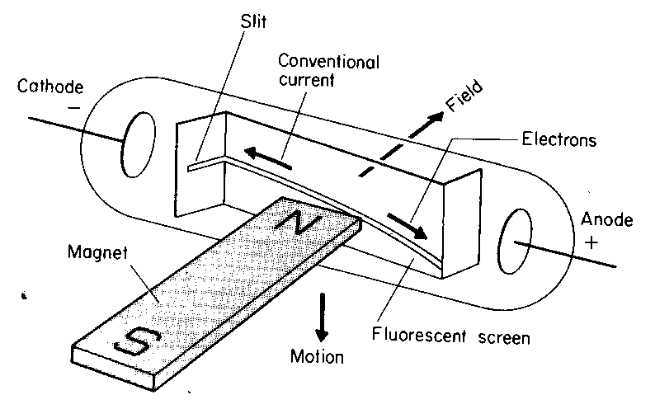

***In a magnetic field, the deflection of the cathode rays is determined using Fleming’s Left hand rule.***

***N.B. Cathode rays flow in the opposite direction of conventional current.***

**EXPERIMENT TO SHOW THAT CATHODE RAYS TRAVEL IN STRAIGHT LINE**

**(THERMIONIC TUBE)**

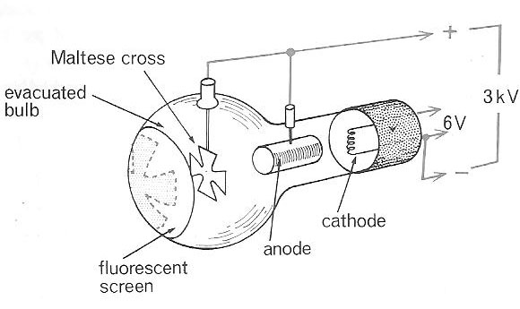

* Cathode rays are incident on the maltase cross.
* A shadow of the cross is formed on the fluorescent screen.
* The formation of the shadow verifies that cathode rays travels in a straight line.

**THE CATHODE RAY OSCILLOSCOPE (C.R.O)**

Thermionic emission is utilized in the cathode ray oscilloscope (C.R.O) X –ray tube, TV etc

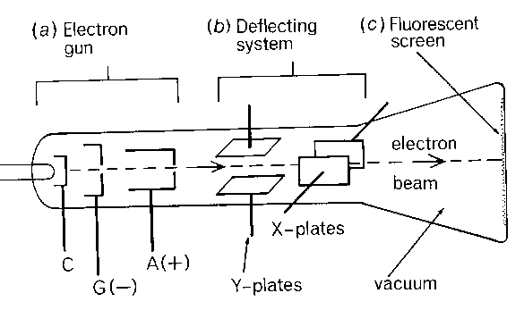

The C.R.O consists of three main components.

1. **THE ELECTRON GUN**

The electron gun consists of the following parts

**(a) The cathode**, **C** – used to emit electrons by thermionic emission.

(b)**The control grid, G** – this is connected to low voltage supply and is used to ***control the number of electrons*** passing through its central hole from the cathode to the anode. It acts as the ***brightness*** control.

(c)**The anode** – it accelerates the electrons and also focuses them on to the screen.

N.B

Since the grid controls the number of electrons moving towards the anode. It consequently controls the brightness of the spot on the screen.

1. **DEFLECTING SYSTEM**

This consists of the X and Y plates. They are used to deflect the electron beam horizontally and vertically respectively.

1. **FLUORESCENT SCREEN.**

This is where the electrons beam is focused to form a bright spot.

**How the cathode ray oscilloscope works:**

* The cathode is heated by a low voltage power supply.
* The cathode emits electrons by thermionic emission.
* The electrons are attracted and accelerated by the anode and focused onto the screen.
* The grid controls the brightness of the spot on the screen.

**DEFLECTING SYSTEM**

* It consists of the X-plates which are vertical and the Y-plates which are horizontal.
* The X - plates deflects the beam of electrons horizontally.
* The Y- plates deflect the beam of electrons vertically.

**FLUORESCENT SCREEN**

* It produces a spot of light when electrons hit the screen.

**The Time base.**

* This is the circuit connected to the X – plates and is used to move the bright spot on the screen horizontally.
* The time base uses a voltage referred to as a saw – tooth voltage.

sweep

Fly back

Time

Volts

When the voltage rises, the spot moves to the right with uniform speed and then quickly flies back to the original spot as the voltage drops down. The process is rapidly repeated to result into a straight horizontal line across the screen.

1. The appearance of the horizontal line on the screen with ***Time base on X plate only***.

**Different wave forms.**

* 1. When time base (x- plate) is switched on and there is no signal on the y-plate, the spot is deflected horizontally. The horizontal line is observed.
  2. When ***alternating current*** (a.c) is applied to the y- plate and time base (X –plate) is off, the spot is deflected vertically. The vertical line observed.
  3. When **a.c** is applied on the Y-plate and X- plate is on, a wave form is observed on the screen.
  4. When time base is switched off and no signal to the Y- plate, a spot is observed.

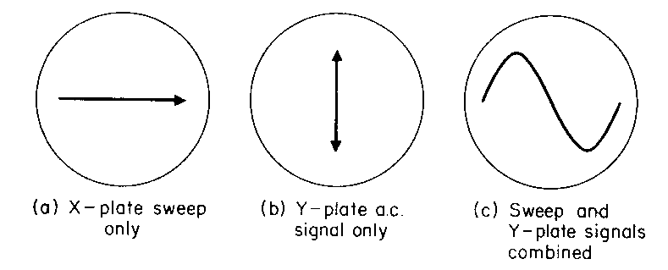

(d) both time base and Y – plate switched of

**Direct current applied to the Y – plate.**

**USES OF A C.R O**

1. **Frequency measurements**

This is achieved by comparing a wave form of known frequency with unknown frequency.

**Method**

Adjust the time base of a C.R.O until one complete wave is obtained without altering the control grid of the C.R.O; apply a signal of known frequency.

Then compare the frequency by counting the number of complete waves.

1. **Measurement of p.d**

A C.R.O can be used as voltmeter because the distance through which the spot is deflected depends on the p.d between the plates

**Method**

Connect a cell 1.5Vto the Y-plate and adjust the grid control until the trace indicating the p.d is 1cm above 0 so that every 1cm deflection represents a p.d of 1.5V

Get unknown p.d and connect it to the Y-plate and then compare the deflection by counting the number of cm deflected. This means that we can measure unknown p.d.

3. Used to study wave forms of current and voltage.

4. Used in manufacture of T.V.

**X – RAYS**

***X – rays are electromagnetic radiations produced when fast moving electrons are stopped by a metal target.***

**TYPES OF X – RAYS**

There are two types of X – rays, namely

1. Soft X- rays ii) Hard X – rays

**Soft X –rays** are produced at low voltages. They have a low penetrating power i.e low frequency and long wave length

**Hard X –rays** are produced at high voltages. They have a high penetrating power i.e very high frequency and short wave length.

**X – RAY PRODUCTION**

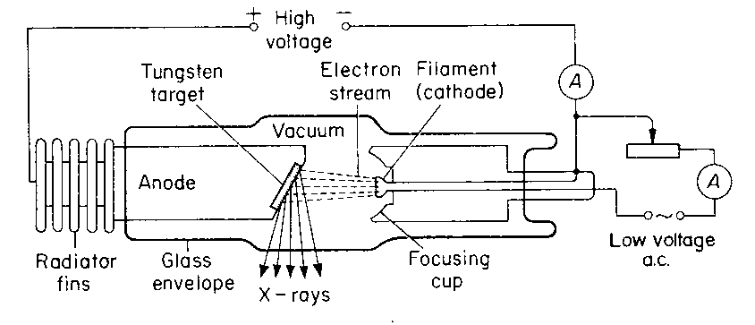 **Production of x-rays.**

* The cathode is heated to emit electrons by thermionic emission using a low voltage supply.
* A large p.d is used to accelerate the electrons towards the anode along a highly evacuated tube.
* On reaching the anode, they hit the metal target of a high melting point and their kinetic energy is converted into **heat** and **X- rays**.
* The heat generated around the anode is conducted away through the copper anode to the cooling (radiator) fins.

**N.B**:

1. The X– ray tube is evacuated to so that electrons can move freely without any hindrance from the air molecules.
2. The target is a metal of high melting point like tungsten so that it does not melt as a result of the great amount of heat generated.
3. The Anode is of copper which rapidly conducts away the heat to the cooling fins.
4. The fins are painted black to quickly radiate heat to the surroundings.

**PROPERTIES OF X- RAYS**

* X-rays readily penetrate through matter.
* They are not affected by electric and magnetic fields (since they carry no charge).
* They have no charge.
* They cause ionization.
* They travel in straight lines.
* They affect photographic material (by blackening it).
* They cause certain materials to fluorescence.
* They are electromagnetic waves and travel at the speed of light.

**USES OF X- RAYS**

1. **Medicine**

In medicine X – rays are used to**;**

* investigate born fractures.
* detect lung tuberculosis.
* treat cancer especially when it hasn’t spread by radiotherapy i.e very hard x-rays are directed to the cancer cells so that the latter are destroyed
* detect internal ulcers along a digestive track
* locate foreign in the body e.g. swallowed metal objects

1. **Industrial use**

In Industries, X – rays are used to;

* detect cracks in car engines and underground pipes.
* locate internal imperfections in welded joints e.g pipes, boilers, storage tanks e.t.c.
* detect cracks in building.

**( c) X-ray crystallography**

* Used to determine inter – atomic spacing in the crystal .

**Differences between cathode rays and X- rays.**

|  |  |
| --- | --- |
| **Cathode rays** | **X- rays** |
| Are negatively charged | Have no charge |
| Are fast moving electrons | Are electromagnetic waves |
| Are deflected by both magnetic and electric fields | Are not deflected by both magnetic and electric fields |
|  |  |

HOW AN X-RAY IS USED TO LOCATE BROKEN PARTS OF A BONE.

* Bones are composed of much denser material than flesh hence, if X- rays are passed through the body, they are absorbed by the bones onto a photographic plate which produces a shadow photograph of the bones.

**Differences between Gamma rays and X- rays.**

|  |  |
| --- | --- |
| **Gamma rays** | **X- rays** |
| They are produced by unstable radioactive material. | They are produced when fast moving electrons are stopped by a metal target. |

**SIMILARITIES BETWEEN X - RAYS AND GAMMA RAYS:**

1. They are both electromagnetic waves.
2. They carry no charge.
3. They are not deflected by both magnetic and electric fields.
4. They penetrate matter.
5. They cause fluorescence.
6. They can cause harmful effects.
7. They travel at the speed of light and in a straight line.

**HARMFUL EFFECTS OF X-RAYS:**

* Hard X -rays destroy healthy body cells.
* They cause genetic mutation or changes.
* They cause damage of eye sight and cause blood cancer.
* They produce skin burns.

**PRECAUTIONS FOR SAFETY**

* Avoid unnecessary exposure to X –rays.
* Keep exposure time as short as possible.
* The X- ray beam should only be restricted to parts of the body being investigated.
* Workers dealing with X-rays should wear shielding jackets with a layer of lead.
* Exposure should be avoided for unborn babies and very young children.
* Rooms where X- ray machines are located (e.g. hospitals and industries) are made of thick concrete walls to absorb stray radiations.

**PHOTO ELECTRIC EMISSION:**

This is the emission of electrons from a certain metal plate e.g zinc plate, when electromagnetic radiations of short wave length fall on it.

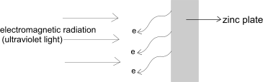

**PHOTOELECTRONS:**

***Photoelectrons are the electrons emitted by a metal by the process of photoelectric effect.***

Photoelectrons are emitted from any metal if the ***wavelength*** of incident electromagnetic radiation is below a certain critical value called the ***threshold wavelength***.

**(OR** if the ***frequency*** of the incident electromagnetic radiation is above the critical ***threshold frequency.)***

**WORK FUNCTION:**

*The* **Work function** *is the* ***minimum frequency*** *of the incident radiation required to eject a photoelectron from a particular metal surface****.***

* The number of photoelectrons emitted from the metal surface depends on

1. the ***intensity of the incident radiation.*** Increasing intensity, increases the number of electrons emited.
2. *the* ***type of metal.***

* The incident radiation provides sufficient energy to overcome the binding forces of the metal and the excess energy is converted to into kinetic energy which the electrons use to escape from the metal surface.

**THE PHOTOELECTRIC CELL**.

* The photoelectric cell uses photoelectric effect to convert light energy into electric energy.
* The strength of the current produced depends on the intensity of the incident light radiation on the metal.

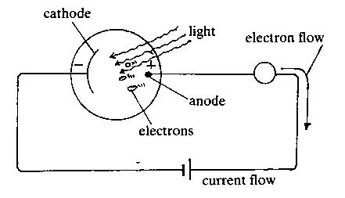

Evacuated transparent tube

* When a suitable radiation falls on the zinc cathode, it emits electrons by photoelectric emission.
* The anode attracts the electrons which then pass through an external circuit causing an electric current.

**N.B** If gas is introduced into the tube, the current decreases slowly because te gas particles collide with the electrons, hence reducing the number of electrons reaching the anode.

**APPLICATIONS OF PHOTOELECTRIC EFECT:**

Photoelectric effect is applied in:

1. Burglar alarms.
2. Automatic lighting systems
3. In solar calculators.
4. Television cameras
5. Automatic door systems
6. Sound track on a film.

**EXPERIMENT TO BEMONSTRATE PHOTOELECTRIC EFFECT:**

Zinc plate

Charged electroscope

Ultra violet lamp

When Ultra violet light is incident on a clean zinc plate placed on the cap of a gold leaf electroscope:

* If the ***electroscope is uncharged***, the leaf initially rises indicating that is acquiring charge.
* If the ***electroscope is negatively charged***, the leaf divergence slowly decreases indicating that is losing charge.
* If the ***electroscope is positively charged***, the leaf initially rises indicating that is acquiring charge.
* If the ***electroscope is positively charged***, no loss of charge is observed. The photoelectrons are attracted back to the zinc plate and electroscope.

**Conclusion:**

The Zinc plate emits photoelectrons when ultra violet radiation falls on it.

.

